**Web Tracker Analysis Using Ghostery**



**Introduction**



Ghostery is a Chrome extension that detects and blocks tracking technologies on websites, helping users to protect their privacy. This Capture the Flag (CTF) scenario introduces beginners to the basics of using the Ghostery extension to discover and analyze trackers on a given webpage.

**Scenario**

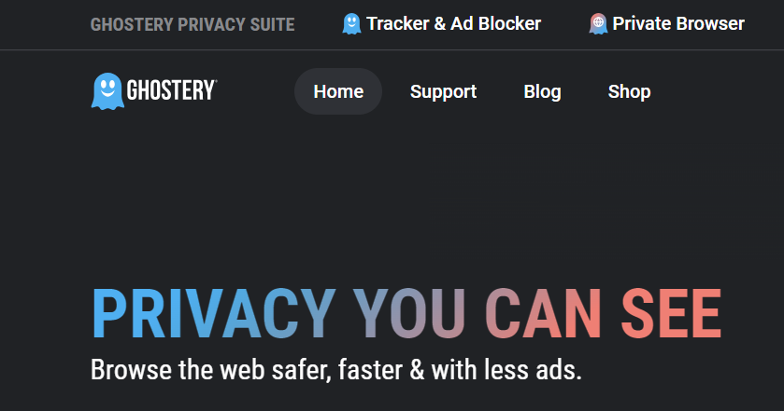

In this scenario, you will use the Ghostery extension to analyze trackers on a specific webpage. Your tasks include identifying different types of trackers and specific tracker attributes to capture flags.

**Process**

Step 1: Go to the Link provided below and add the extension to your google chrome.

Step 2: After that click on the extension menu and open the Ghostery extension.

<https://chromewebstore.google.com/detail/ghostery-tracker-ad-block/mlomiejdfkolichcflejclcbmpeaniij>

Step 3: Open wikipedia: <https://www.wikipedia.org/>

**Questions**

Flag 1: How many hosts are detected on the Wikipedia homepage?

Answer:1

Flag Captured.

Flag 2: How much time does it track continuously?

Answer: 1 hour

**Hint:**

